**RESEARCH PAPER ACCEPTANCE PROOF**

**Conference Details**

**Title of Paper: From Fields to Sharing Yields: A Novel Approach to Affordable Farm Equipment Access**

**Name of Conference: DoSCI 2024**

**Date of Acceptance: 19th February,2024  
Date of Publication: SOON**

**Proof of Submission:**

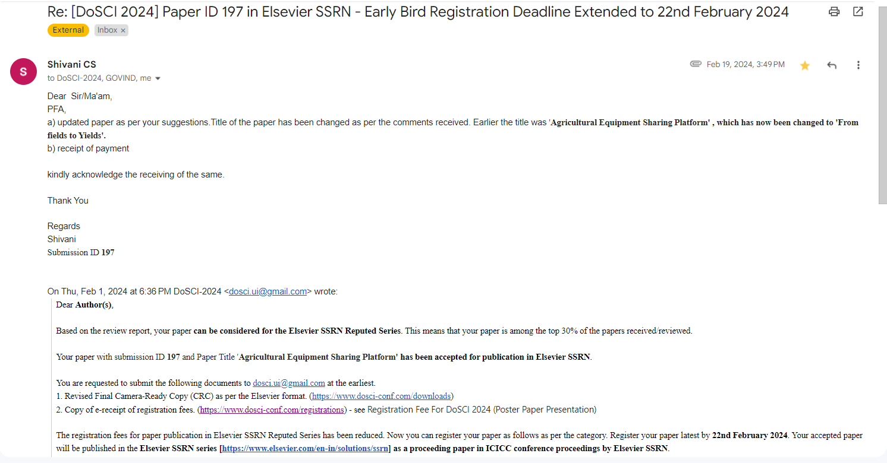

**Patent Details:**

**Through KIET**

